**Question 01**

TITLE My First Program (Test.asm)

INCLUDE Irvine32.inc

.data

A DWORD 0

B DWORD 1

.code

main PROC

mov eax, A

mov ebx, B

mov edx, 0

mov ecx, 8

; The register edx shows the value of the elements of the Fibonacci series

call DumpRegs

mov edx, ebx

call DumpRegs

L1:

mov edx, 0

add edx, ebx

add edx, eax

call DumpRegs

mov eax, ebx

mov ebx, edx

Loop L1

exit

main ENDP

END main

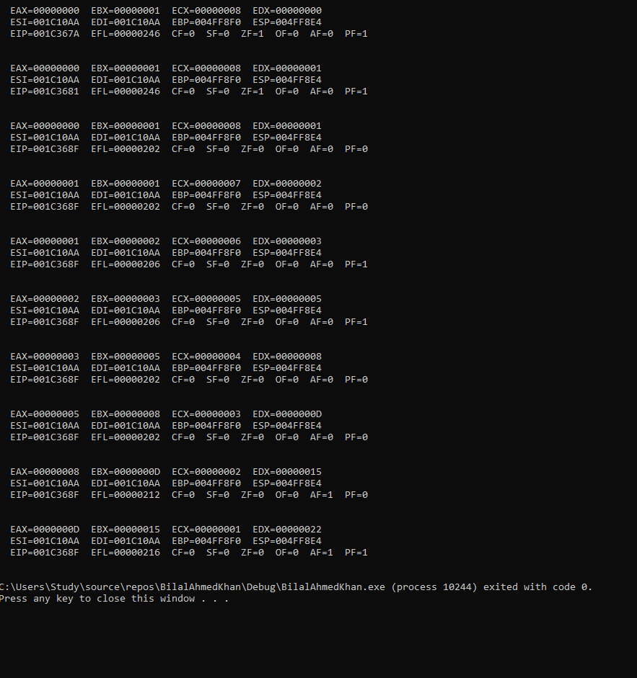

**Question 02**

include irvine32.inc

.data

msg byte "Sorted array :", 0

space byte " ", 0

arr dword 8,5,1,2,6

.code

main proc

mov ecx, 5

outerloop:

mov edx, ecx ; saving value of counter

mov esi, 0

mov ecx, 4

innerloop:

mov eax, [arr + esi]

mov ebx, [arr + esi+4]

cmp eax, ebx

jg swapp

jmp endd

swapp:

mov [arr + esi], ebx

mov [arr + esi+4], eax

endd:

add esi, 4

loop innerloop

mov ecx, edx

loop outerloop

; printing:

mov edx, offset msg

call writestring

mov ecx, 5

mov esi, 0

print:

mov eax, [arr + esi]

call writeInt

mov edx, offset space

call writestring

add esi, 4

loop print

main endp

end main

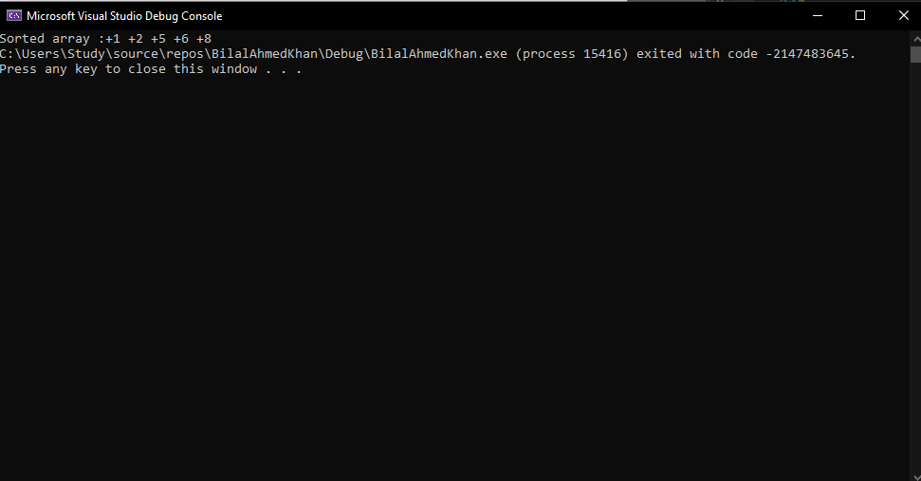

**Question 05**

include irvine32.inc

.data

src byte "Source string", 0

target byte lengthof src dup(0)

.code

main proc

mov ecx, lengthof src

mov esi, 0

l1:

mov ah, [src+esi]

xchg ah, [target+esi]

mov [src+esi], ah

inc esi

loop l1

mov edx, offset target

call writestring

main endp

end main

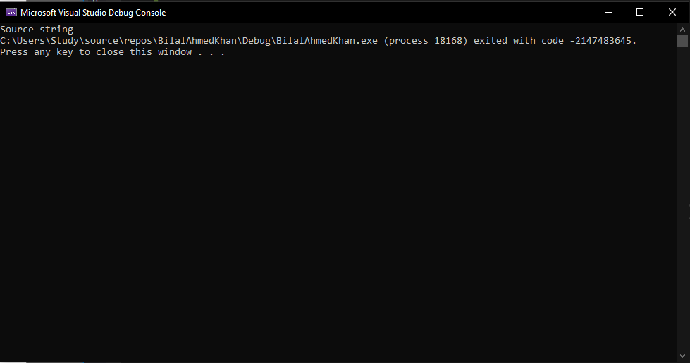

**Question 06**

include irvine32.inc

.data

arr byte 1,2,3,4,5

.code

main proc

mov ecx, lengthof arr

mov esi, 0 ; 1st index

mov edi, 4 ; last index

l1:

mov al, [arr+esi]

mov bl, [arr+edi]

mov [arr+esi], bl

mov [arr+edi], al

inc esi

dec edi

cmp esi, edi

jl endd ; jump if less

mov ecx, 1 ; to break

endd:

loop l1

mov ecx, lengthof arr

mov esi, 0

print:

movzx eax, [arr+esi]

call writeint

inc esi

loop print

main endp

end main

